Function main

Output "Enter the subtotal and a gratuity rate:"

Declare double subtotal

Declare double gratuityRate

Input subtotal, gratuityRate

Declare double gratuity

Declare double total

Assign gratuity = subtotal * gratuityRate * .01

Assign total = subtotal + gratuity

Output "The gratuity is $" + gratuity + " and the total is $" + total

End

**Test Plan**

The purpose of the program is to calculate total cost and gratuity cost of a service with a user input subtotal and gratuity percentage.

**Program Functional Requirements**

1. User needs to be prompted for a subtotal and gratuity percentage amount.
2. The program has to convert the gratuity percentage to a decimal value and evaluate total gratuity payment.
3. The program has to add the total gratuity payment to the subtotal in order to calculate the total.
4. The program has to output the gratuity payment and the total.

**Traceability Matrix**

|  |  |  |  |  |
| --- | --- | --- | --- | --- |
| Test Case | Input/Output | Expected Result | Actual Result | Outcome (p/f) |
| 1 | The user is prompted for subtotal and gratuityRate inputs | A message prompting the user for the 2 inputs appears on the screen | "Enter the subtotal and a gratuity rate: " | pass |
| 2 | 100 subtotal 15 gratuity rate is entered | The gratuity is $15.0 and the total is $115.0 | The gratuity is $15.0 and the total is $115.0 | pass |
| 3 | 200 subtotal 0 gratuity is entered | The gratuity is $0.0 and the total is $200.0 | The gratuity is $0.0 and the total is $200.0 | pass |
| 4 | Two hundred subtotal 10 gratuity is entered | Fails to execute due to invalid input | java.util.InputMismatchException | fail |

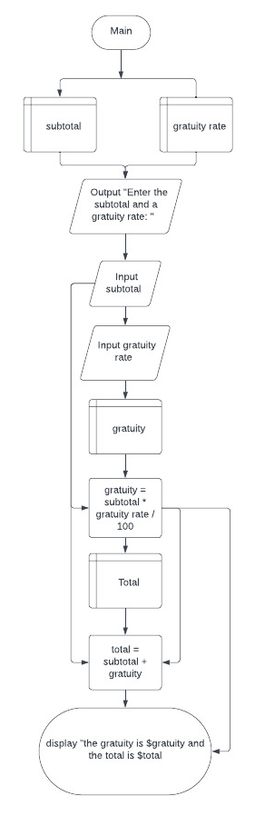

Function main

Declare double investmentAmount

Input investmentAmount

Declare double annualInterestRate

Input annualInterestRate

Declare double monthlyInterestRate

Assign monthlyInterestRate = annualInterestRate / 12

Assign monthlyInterestRate = monthlyInterestRate / 100

Declare double numberOfYears

Input numberOfYears

Declare double futureInvestmentValue

Assign futureInvestmentValue = investmentAmount * (1 + monthlyInterestRate)^(numberOfYears * 12)

Output "Future value is $" + futureInvestmentValue

End

**Test Plan**

The purpose of this program is to evaluate financial return on an initial investment using an interest rate and time period provided by the user.

**Program Functional Requirements**

1. User needs to be prompted for an initial investment, annual interest rate, and time period in years.
2. The program has to convert the annual interest rate to monthly interest decimal.
3. The program has to calculate the investment return using a given formula.
4. The program has to output the investment future value.

**Traceability Matrix**

|  |  |  |  |  |
| --- | --- | --- | --- | --- |
| Test Case | Input/Output | Expected Result | Actual Result | Outcome (p/f) |
| 1 | The user is prompted for investment, interest and time inputs | A message prompting the user for the 3 inputs appears on the screen | Enter investment amount:  Enter annual interest rate in percentage: Enter number of years: | pass |
| 2 | 1000 investment, 3.25% interest, 1 year is input | Future value is $1032.98 | Future value is $1032.98 | pass |
| 3 | 1000 investment, 3.25% interest, 0 years is input | Future value is $1000.0 | Future value is $1000.0 | pass |
| 4 | Two hundred investment, 3.25% interest, 1 year is input | Fails to execute due to invalid input | java.util.InputMismatchException | fail |

